BASIC PROGRAMMING

JOBSHEET 7

GROUP 7



**GROUP NAME :**

1. Muhammad Baihaqi Aulia Asy’ari (18_2241720145)
2. Maulia Balqis Ansya Aulia (16_2241720246)
3. Hawa Esanda (11_2241720079)

# 2.1 Experiment 1: Loop Review

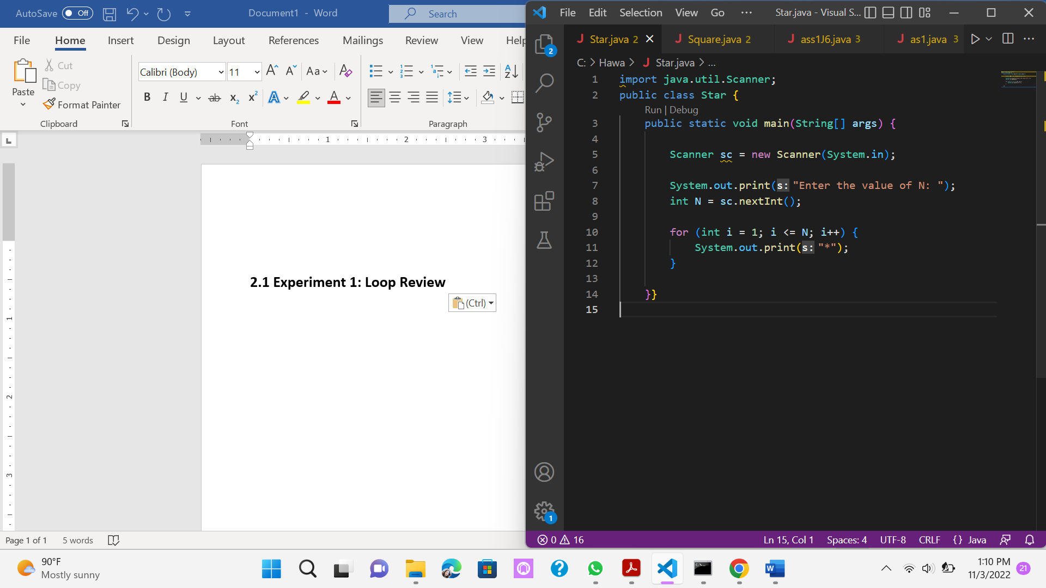

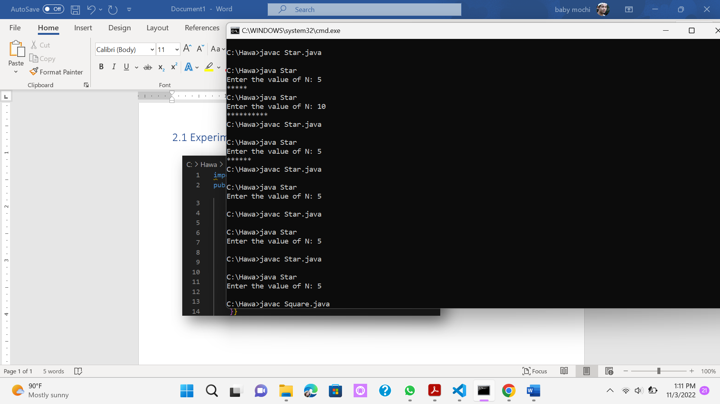

## Questions!

1. If in **for** loop, the initialization **i = 1** is changed to **i = 0**, what is the result? How can It be like that?

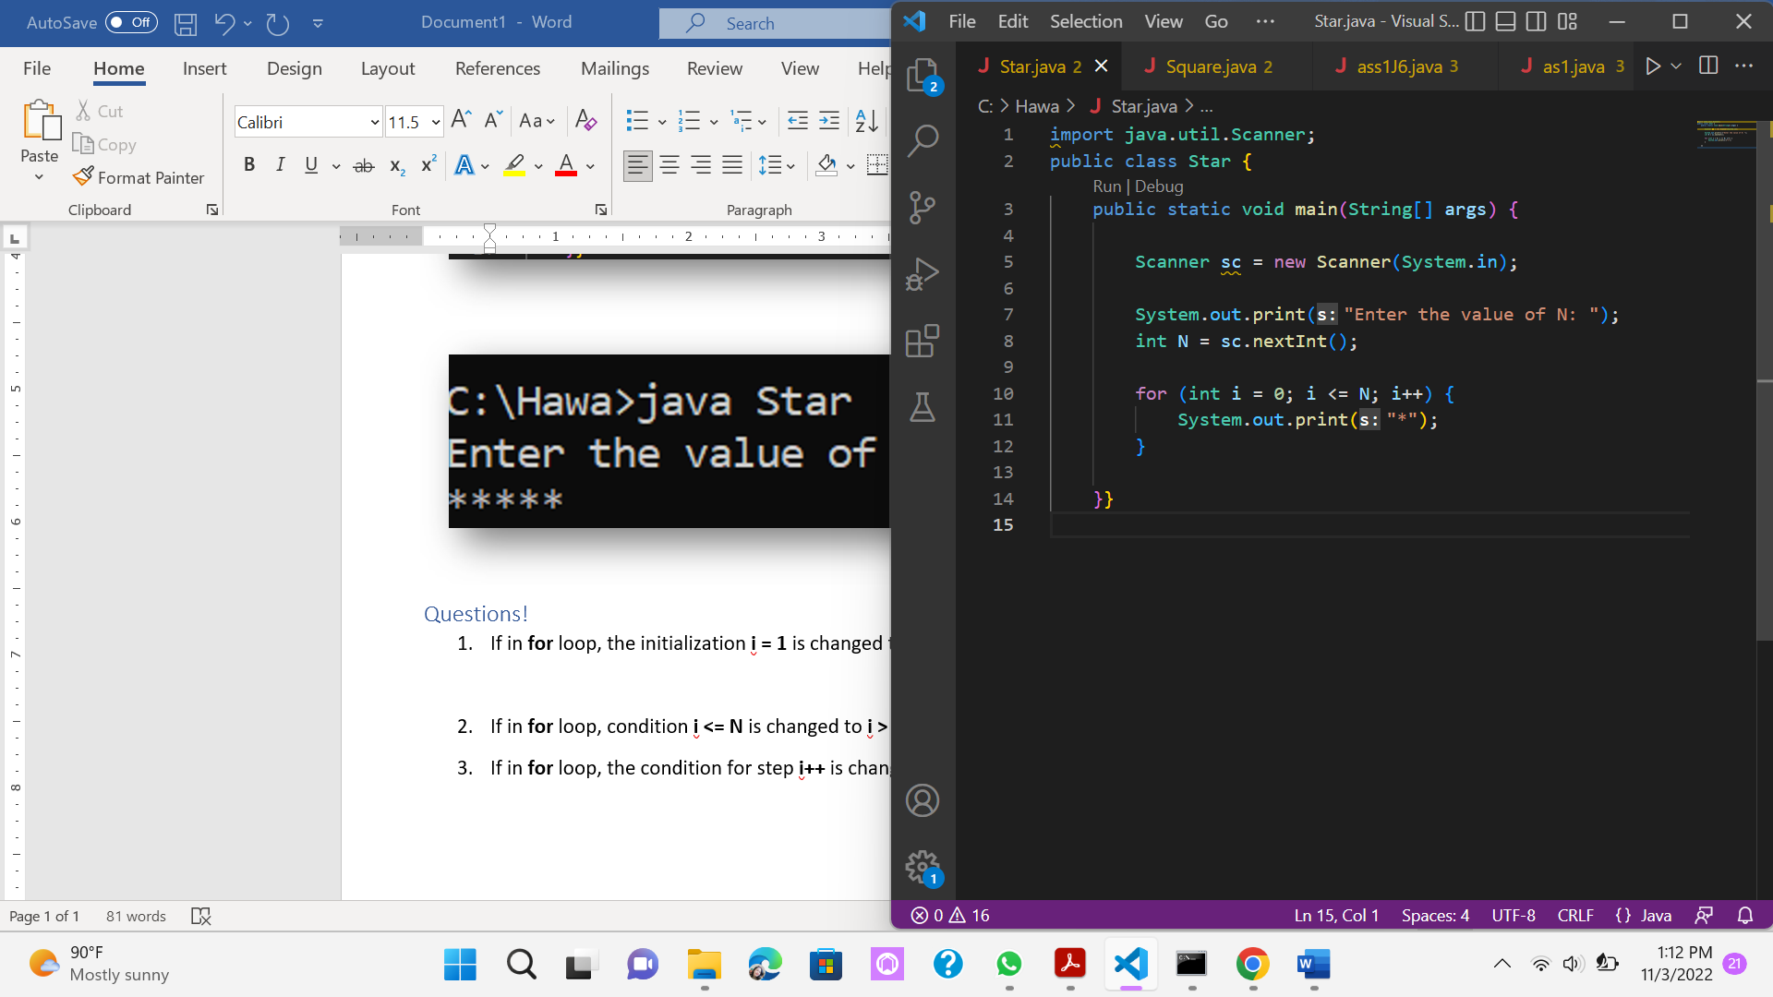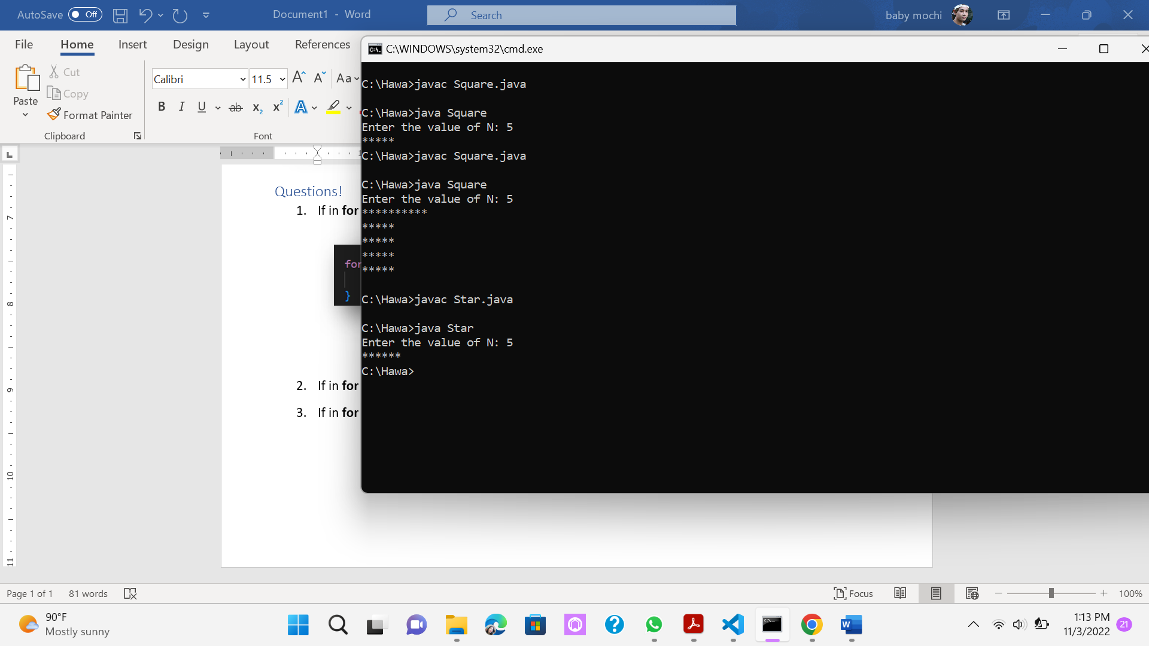

1. If in **for** loop, condition **i <= N** is changed to **i > N**, what is the result? How can It be like that?

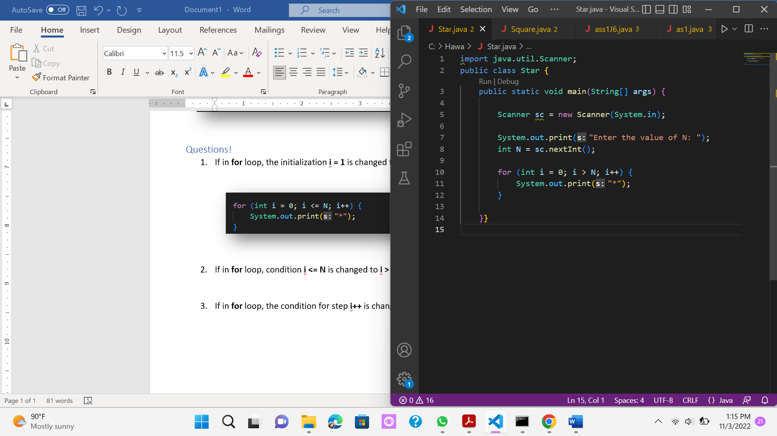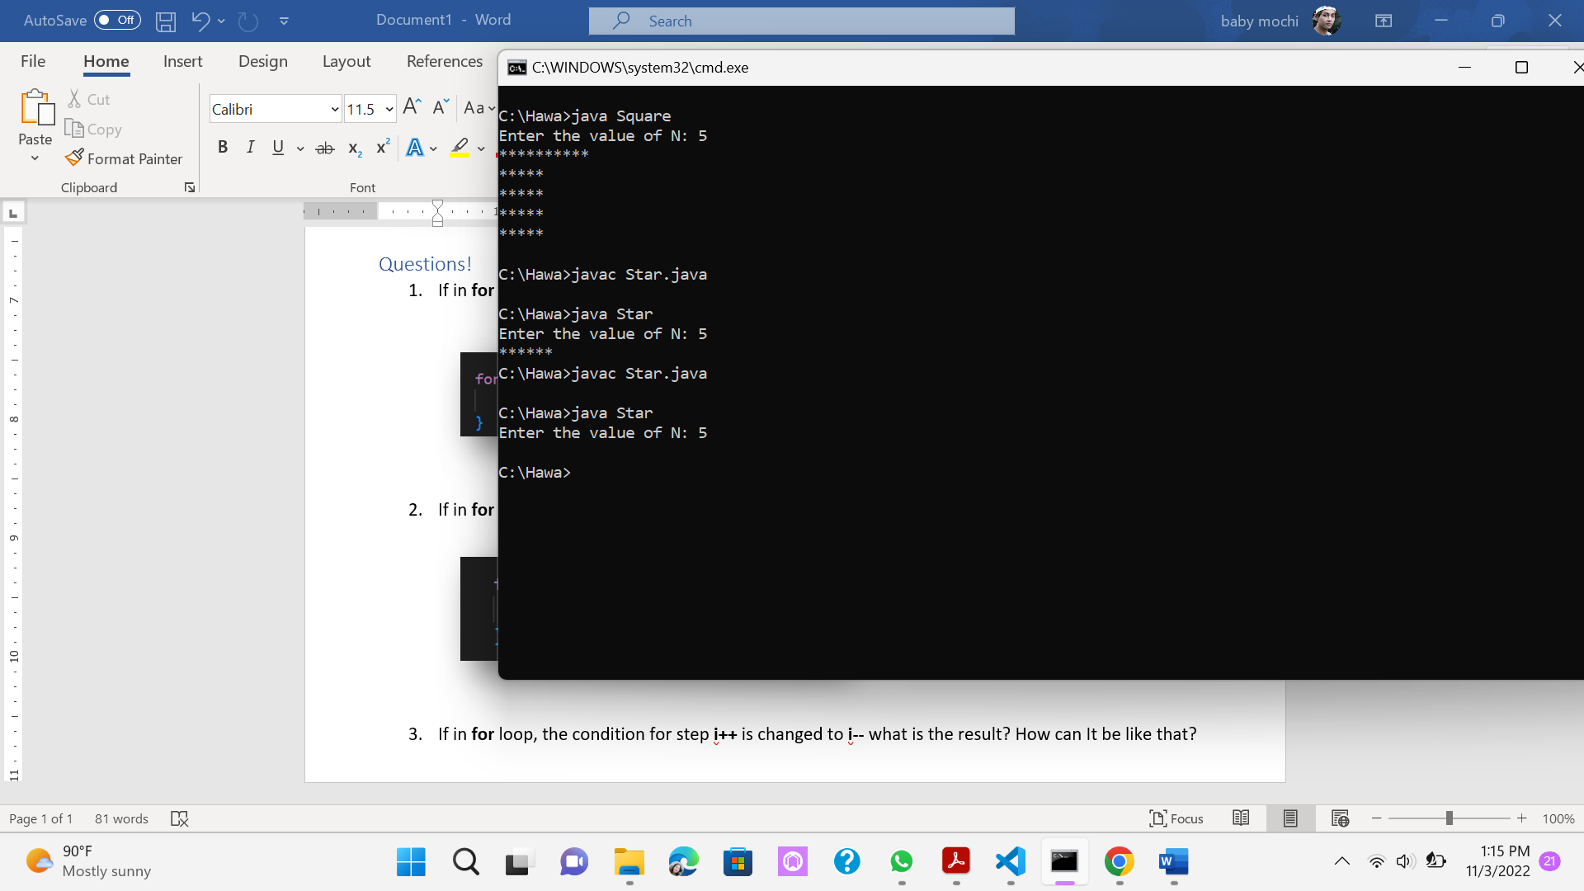

1. If in **for** loop, the condition for step **i++** is changed to **i--** what is the result? How can It be like that?

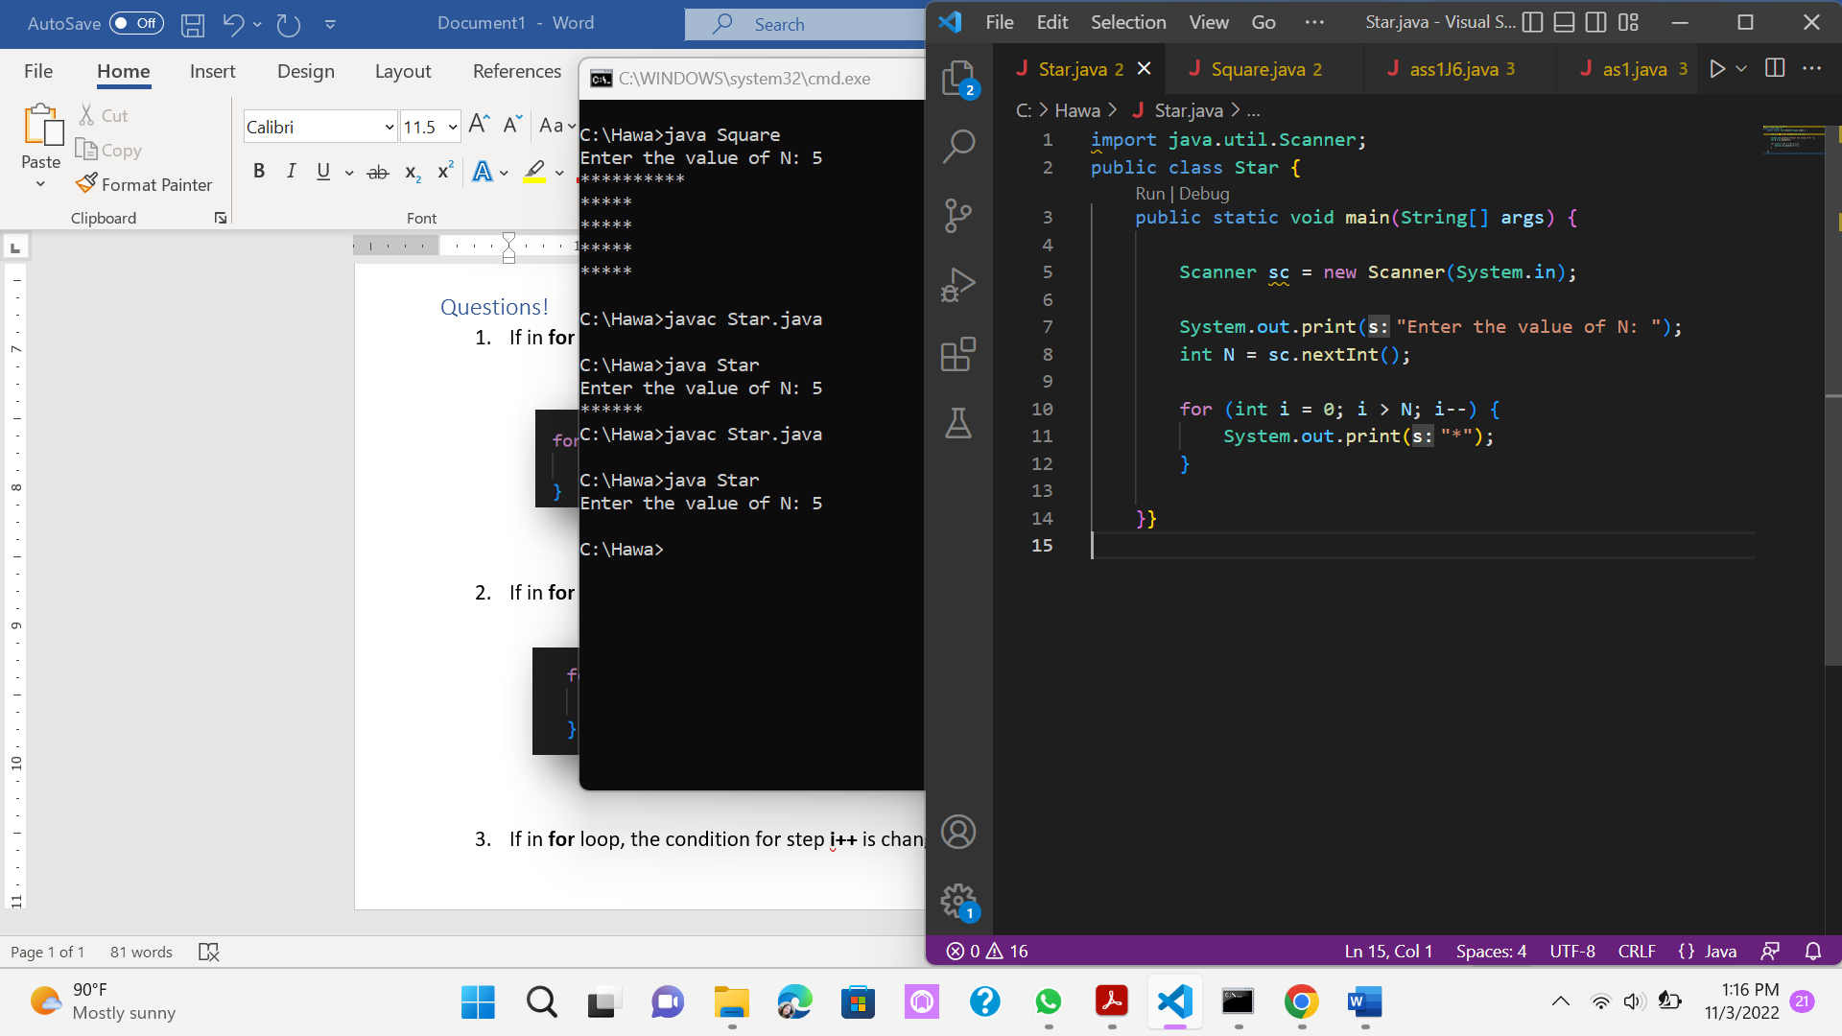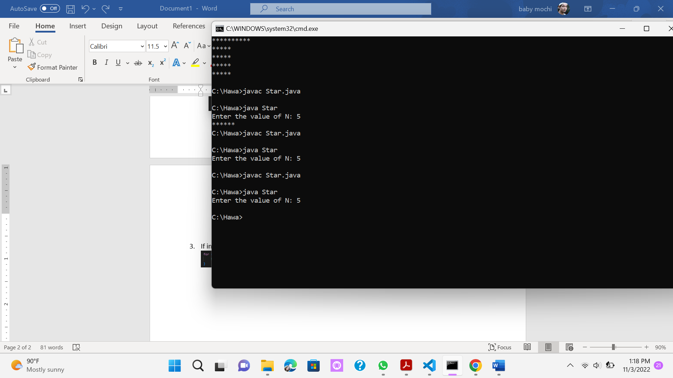

# 2.2 Experiment 2: Square Star

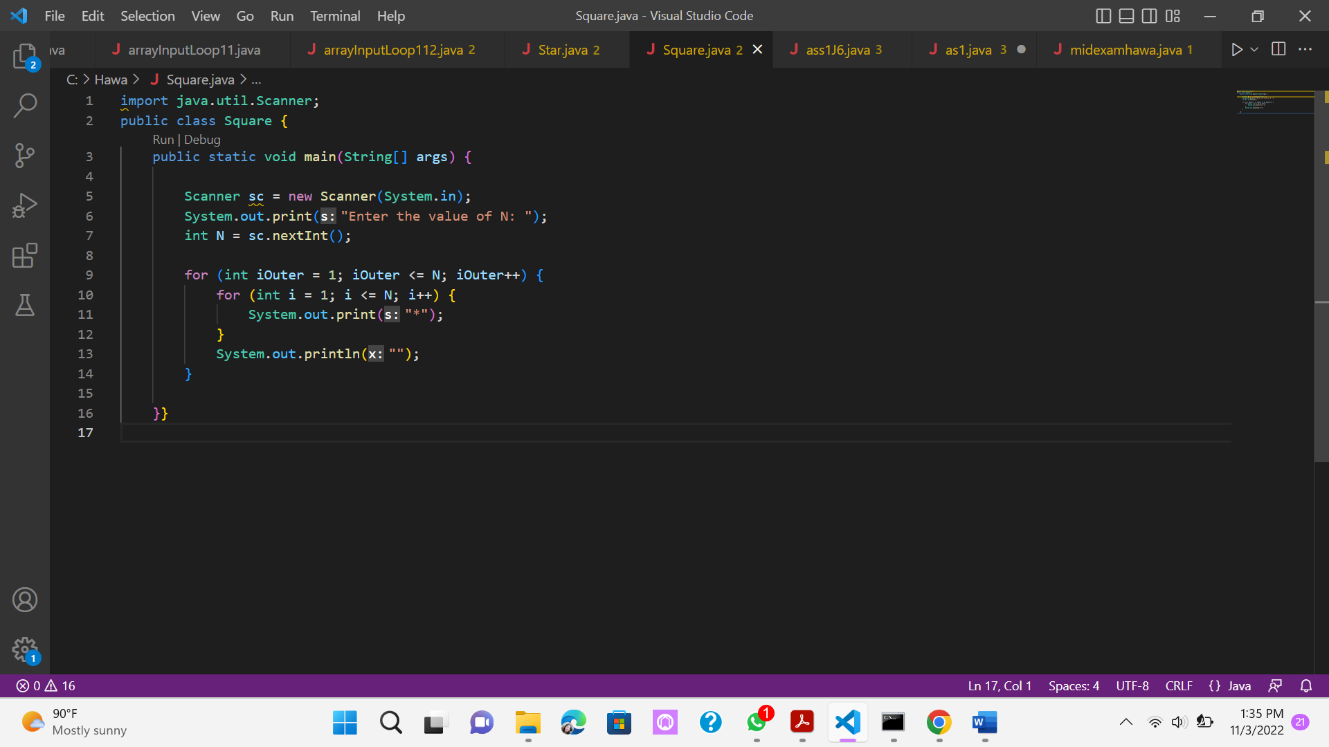

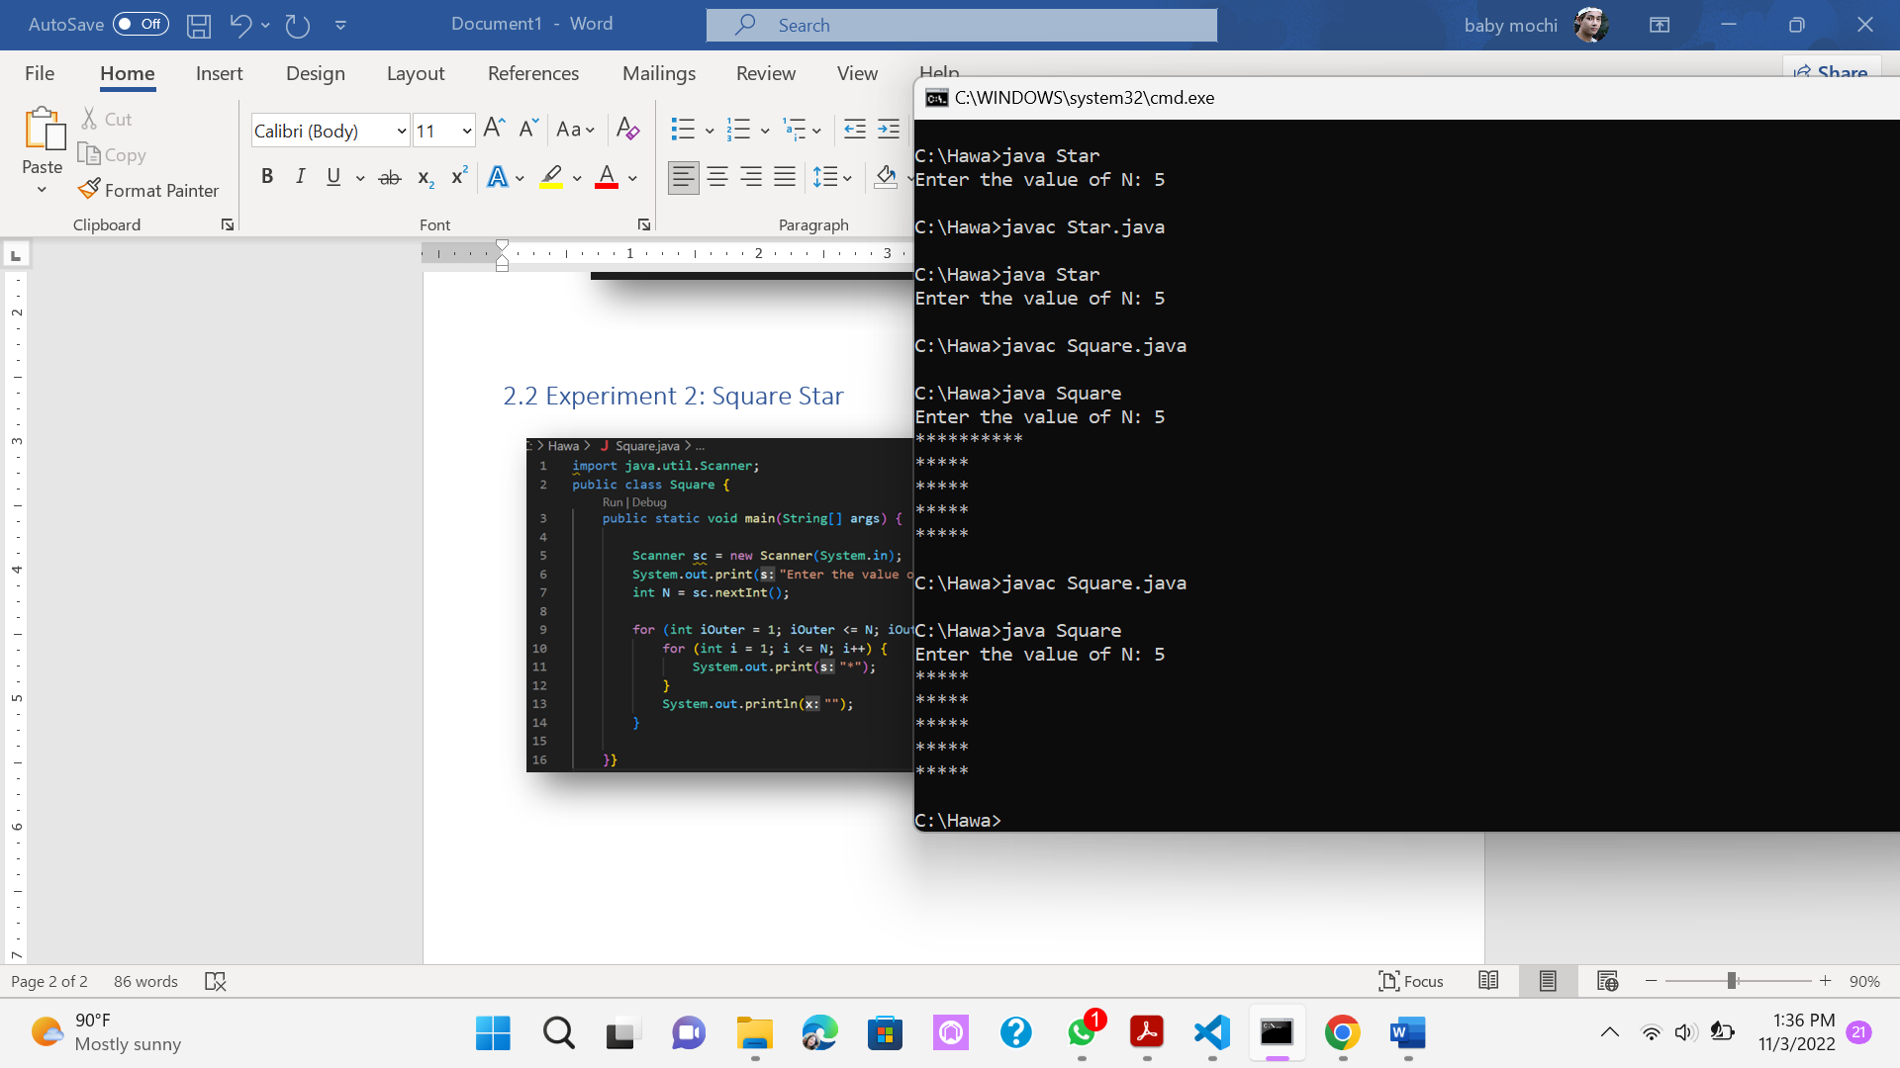

## Questions!

1. Pay attention to outer loop. If in **for** syntax, the initialization **iOuter = 1** is changed to **iOuter = 0**, what is the result? How can it be like that?

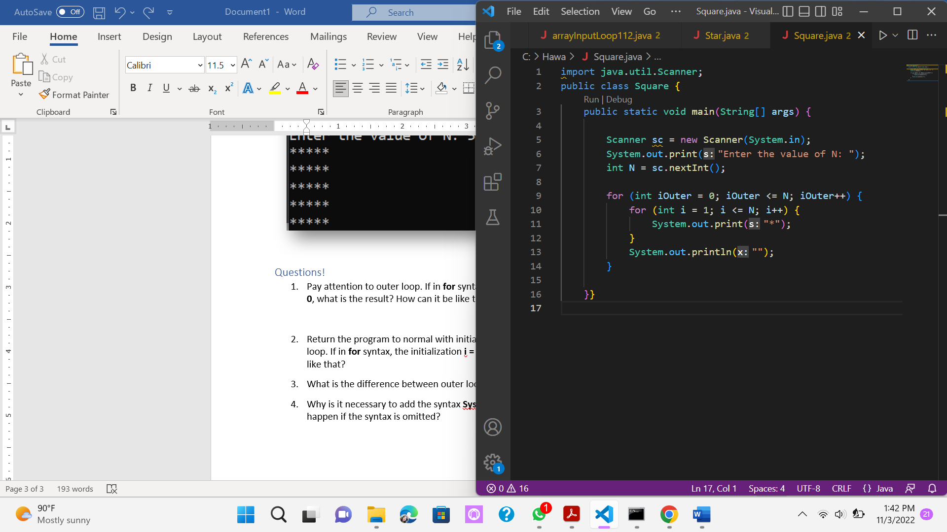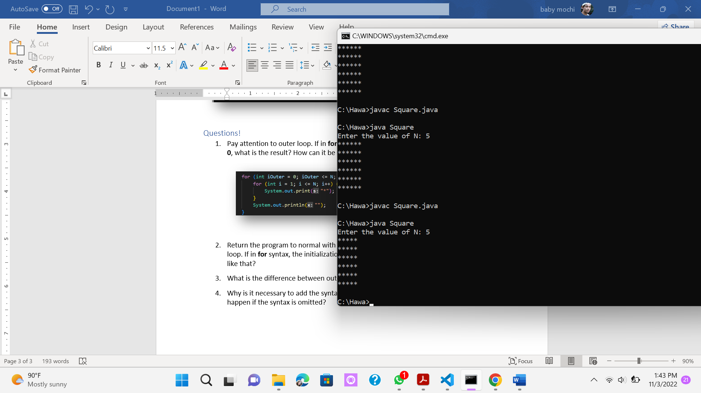

1. Return the program to normal with initialization **iOuter = 1**. Then pay attention to the inner loop. If in **for** syntax, the initialization **i = 1** is changed to **i = 0**, what is the result? How can it be like that?

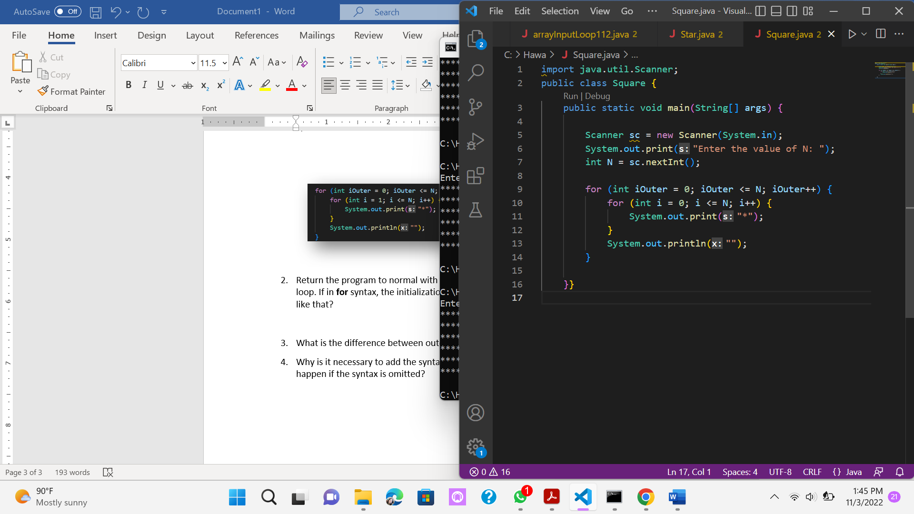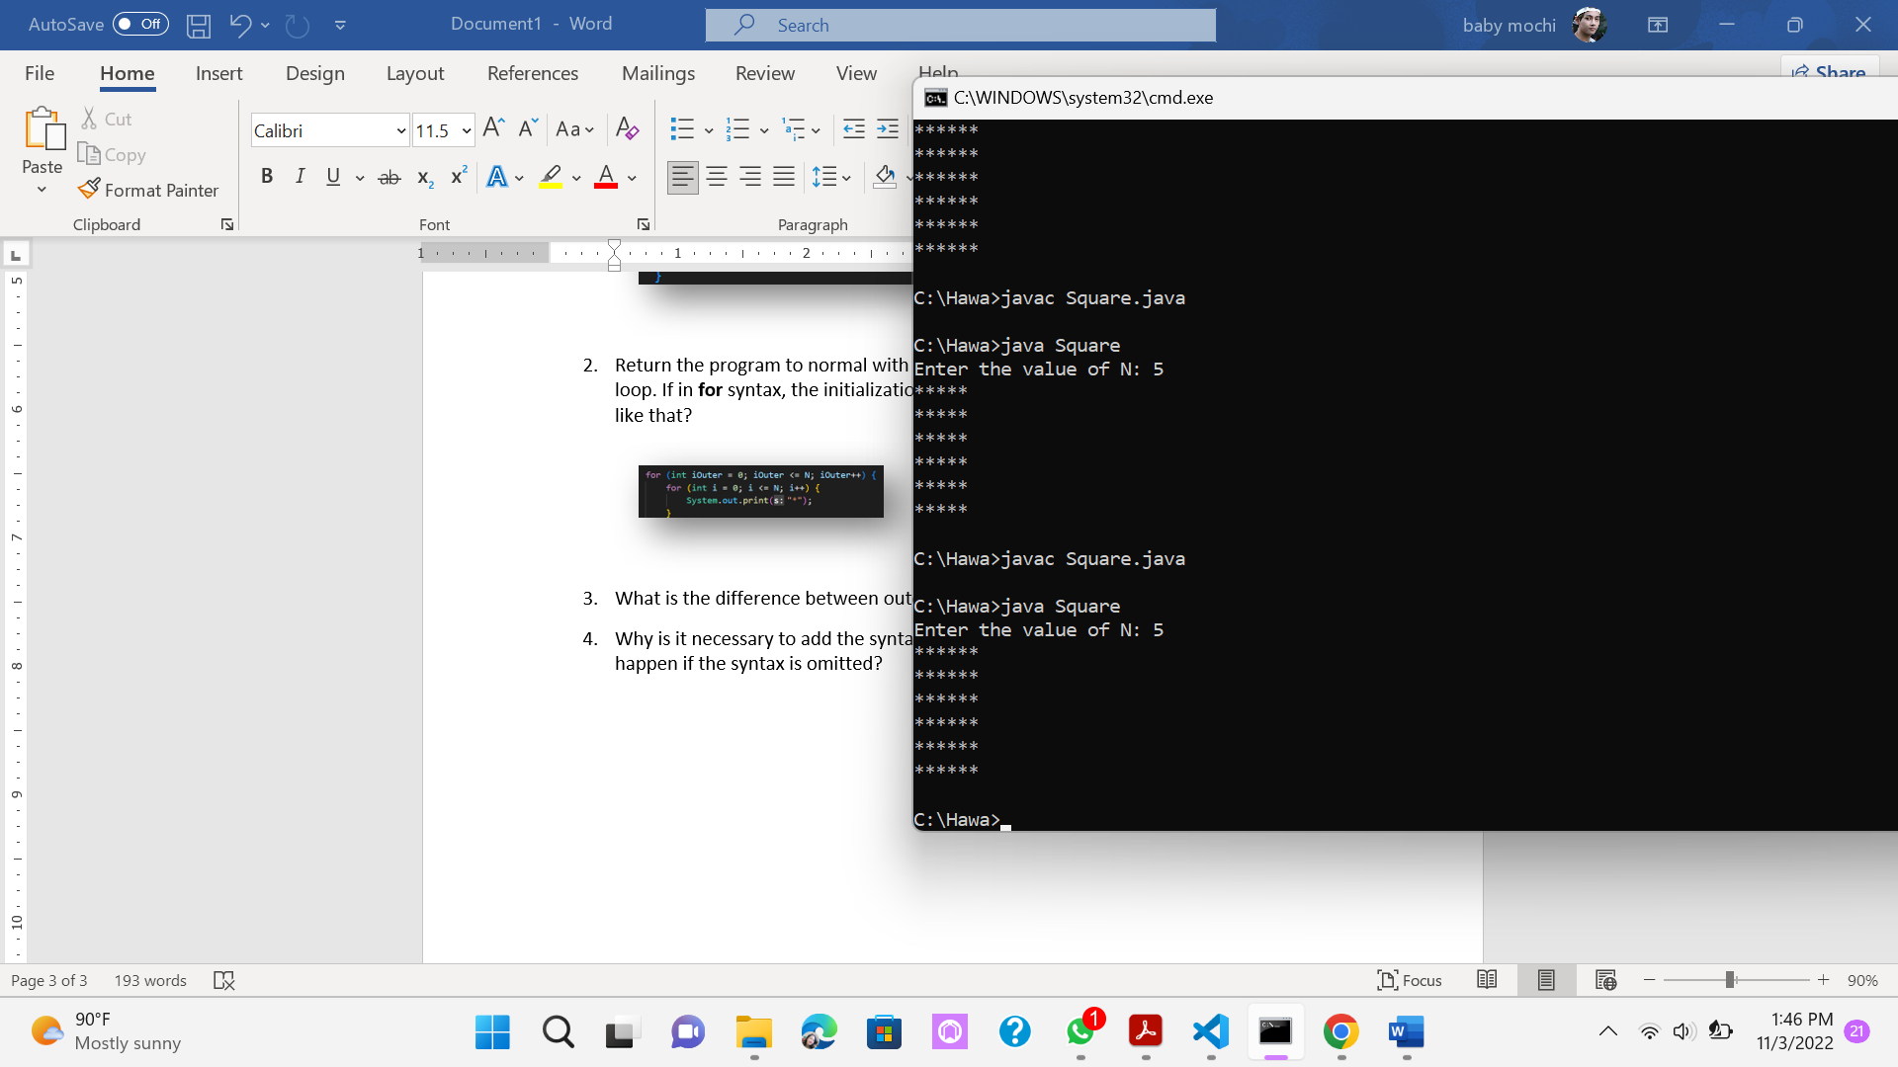

1. What is the difference between outer loop and inner loop?
2. Why is it necessary to add the syntax **System.out.println();** under inner loop? What will happen if the syntax is omitted?

# 2.3 Experiment 3: Triangle Star

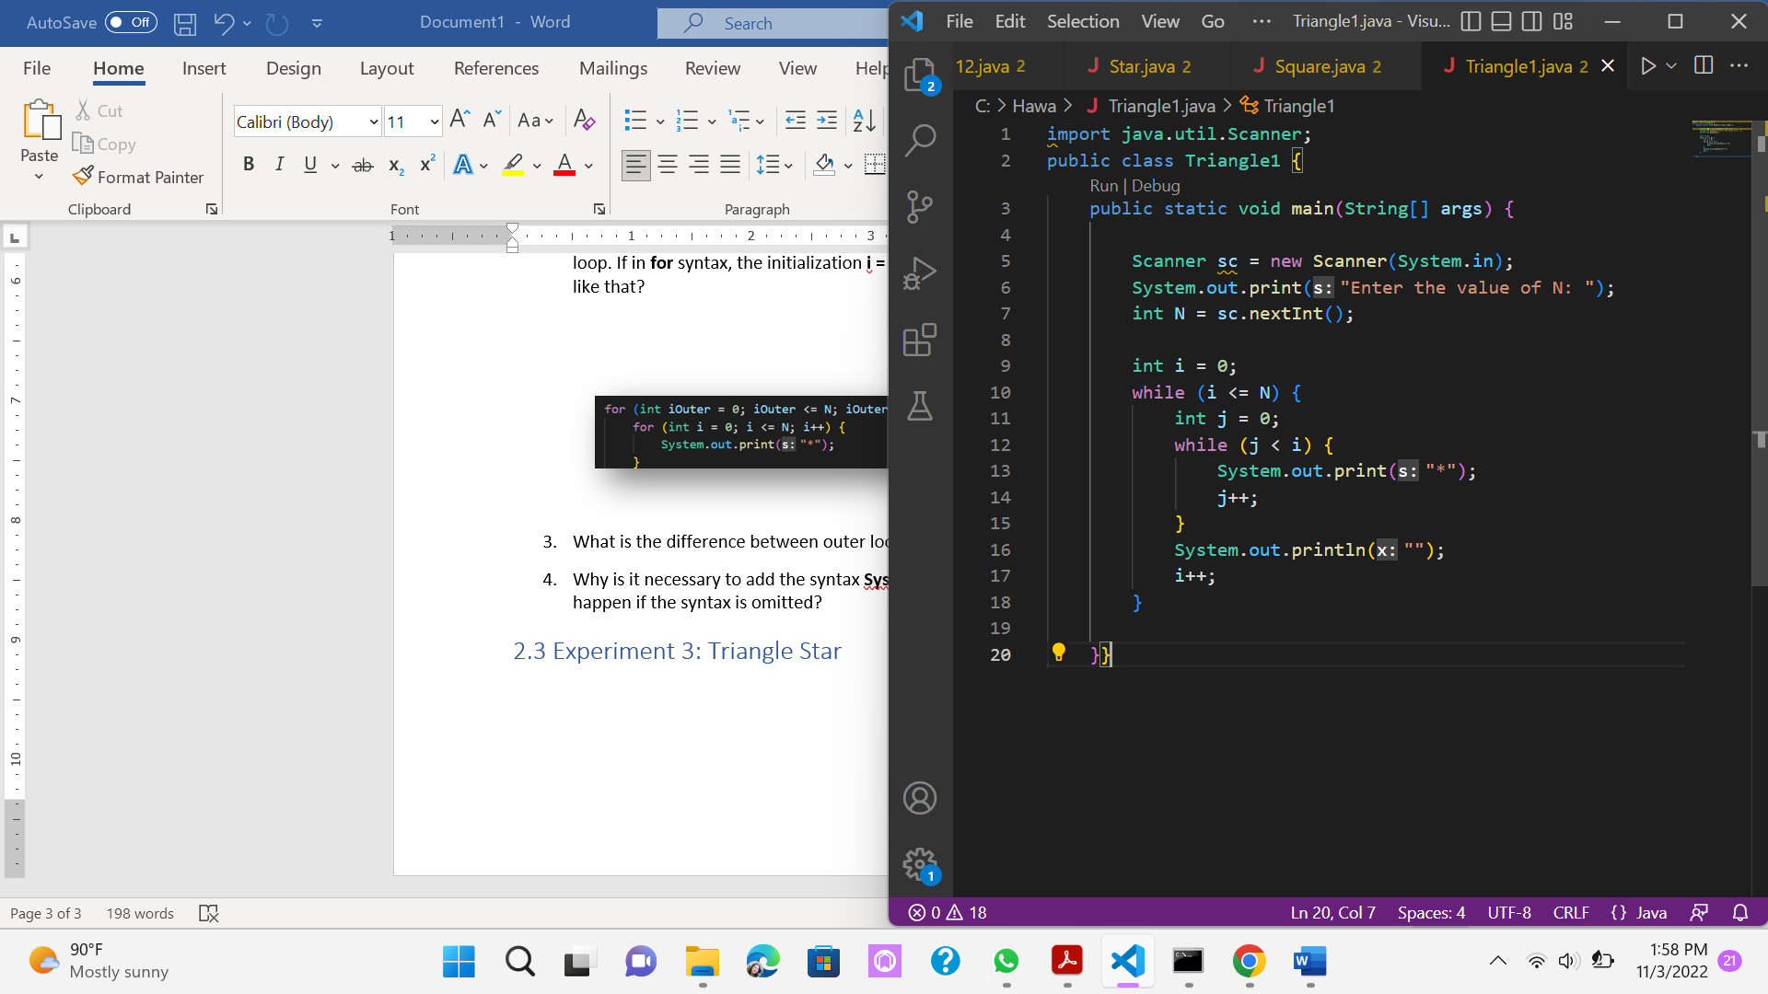 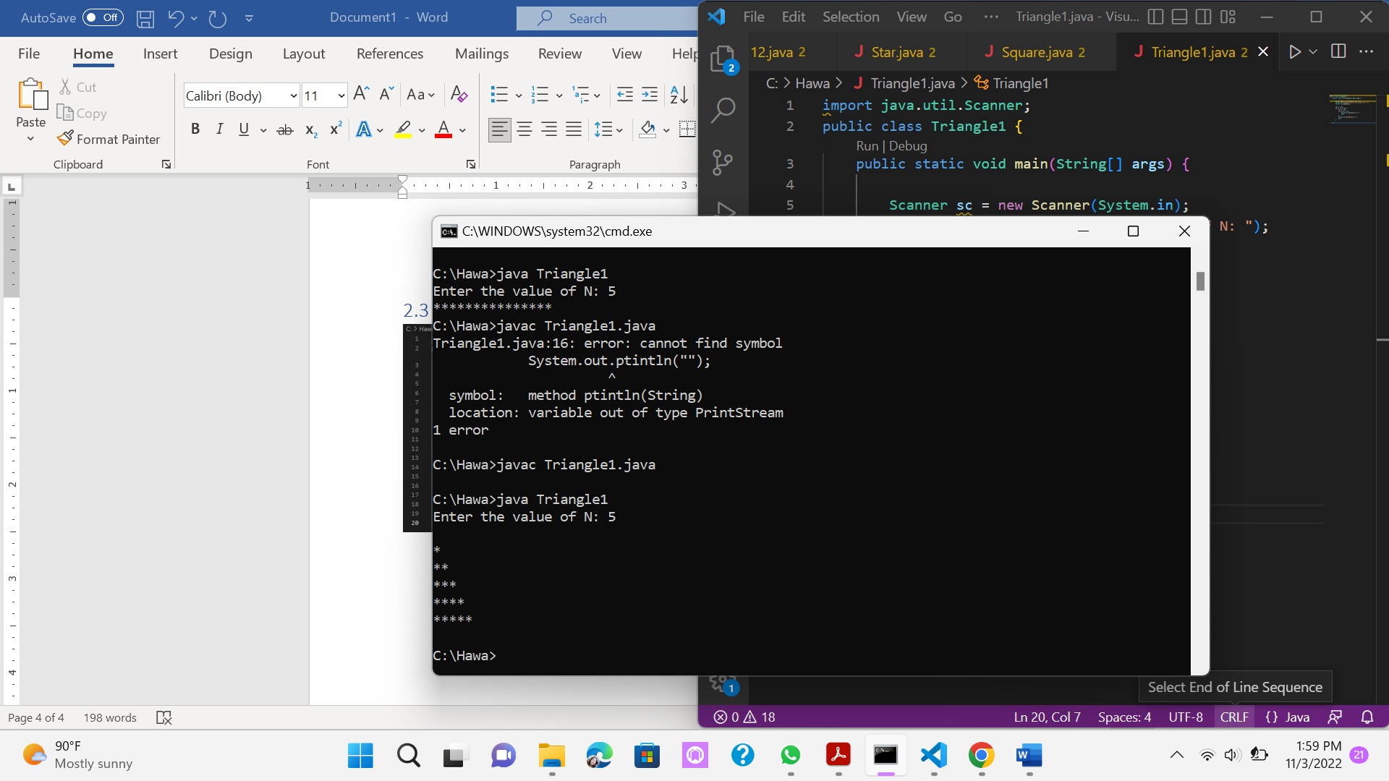

## Questions!

1. Look at the results, is the output generated with a value of N = 5 in accordance with the following display?



1. If not, which parts should be improved or added? Describe any parts that need to be improved or added!

Answer : we should added 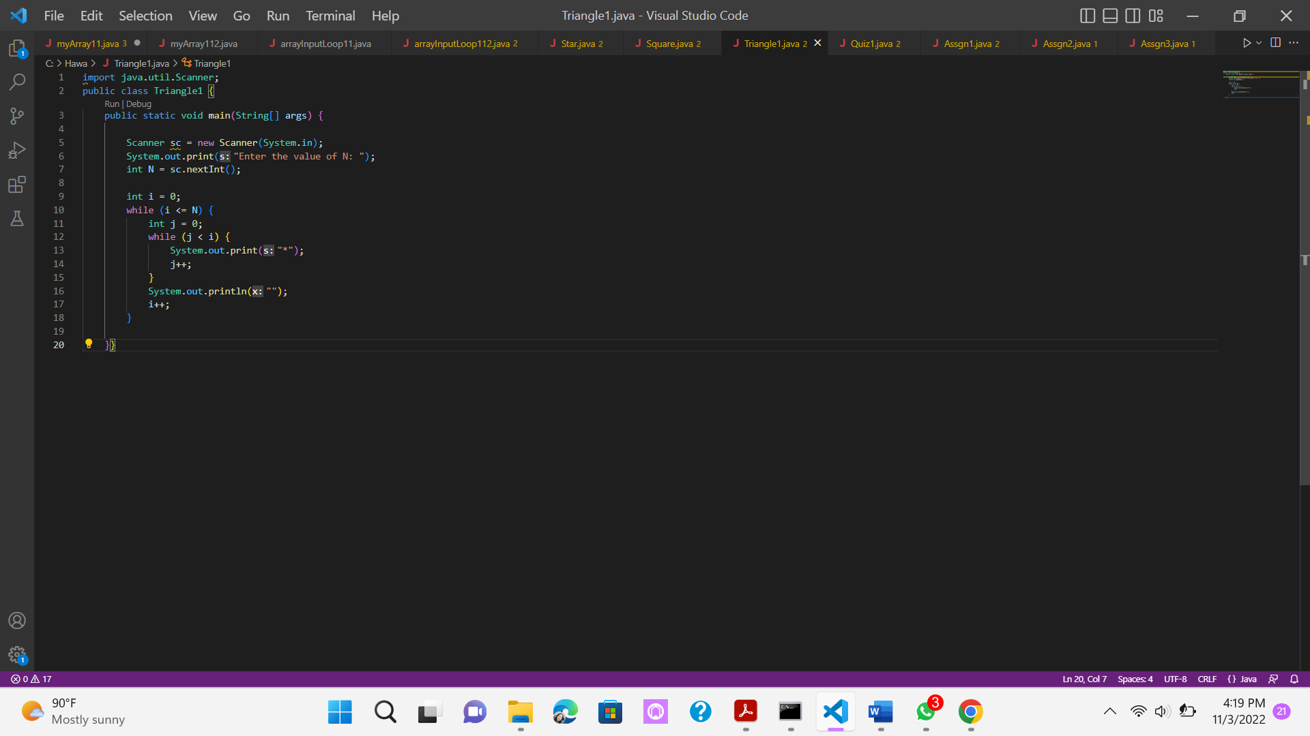 before 

# 2.4 Experiment 4: Guess the Number Quiz

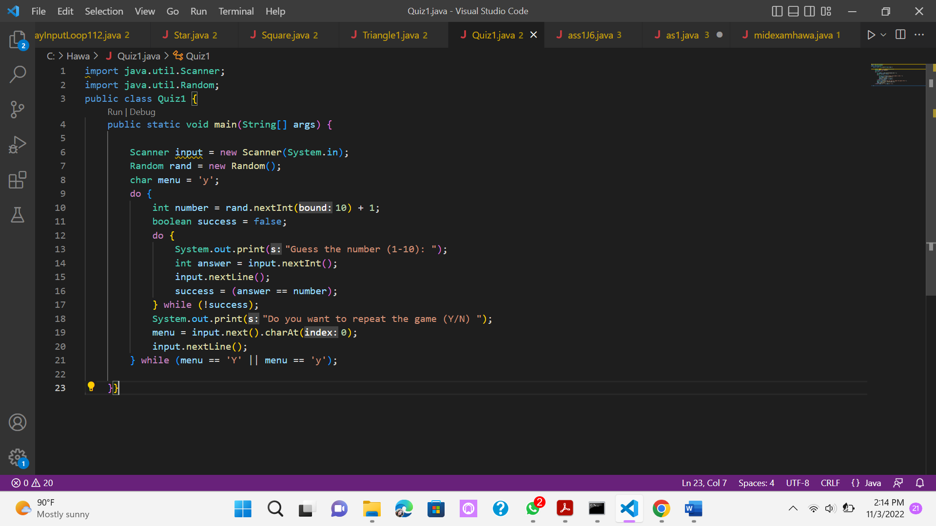

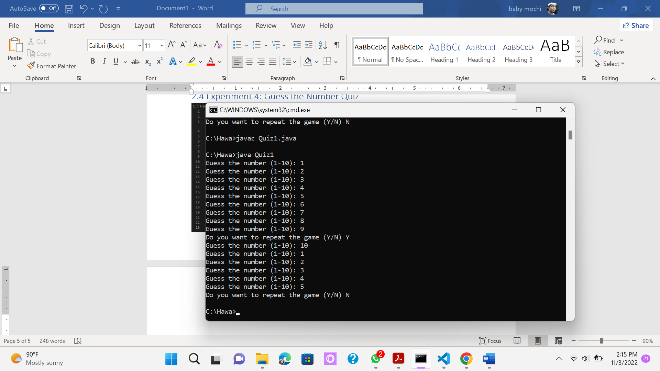

## Questions!

1. Explain the program flow in Experiment 4!
2. What must be done to discontinue (not repeat) the game?
3. Modify the program above, so that it can display information about: input the guess value entered by the user, whether it is smaller or greater than the answer (number) randomly determined by the computer!

# 3. Assignments

1. Create a program to print a numeric triangle display as below based on the N input (minimum N value is 3). Example N = 5

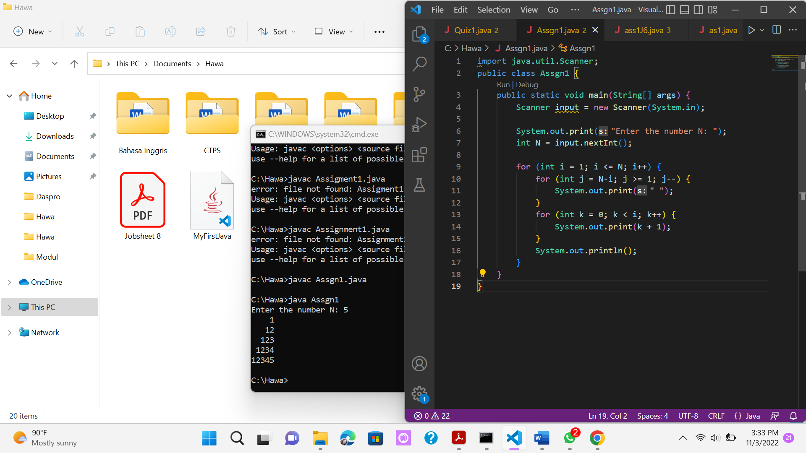 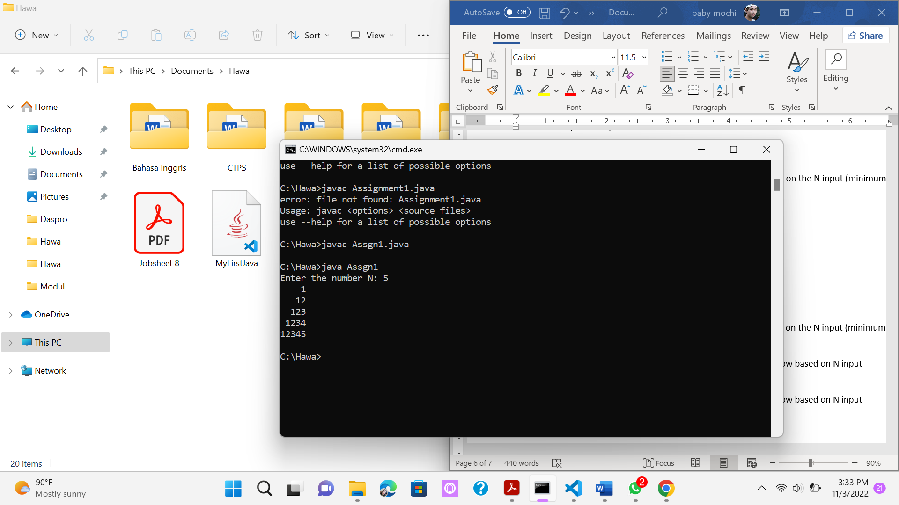

1. Create a program to print the star triangle view shown below based on the N input (minimum N value is 5). Example N = 7

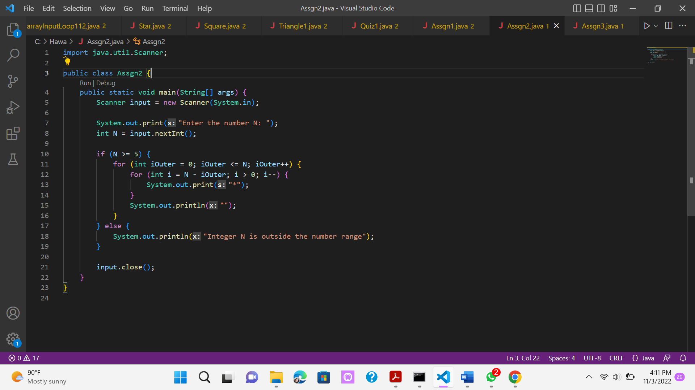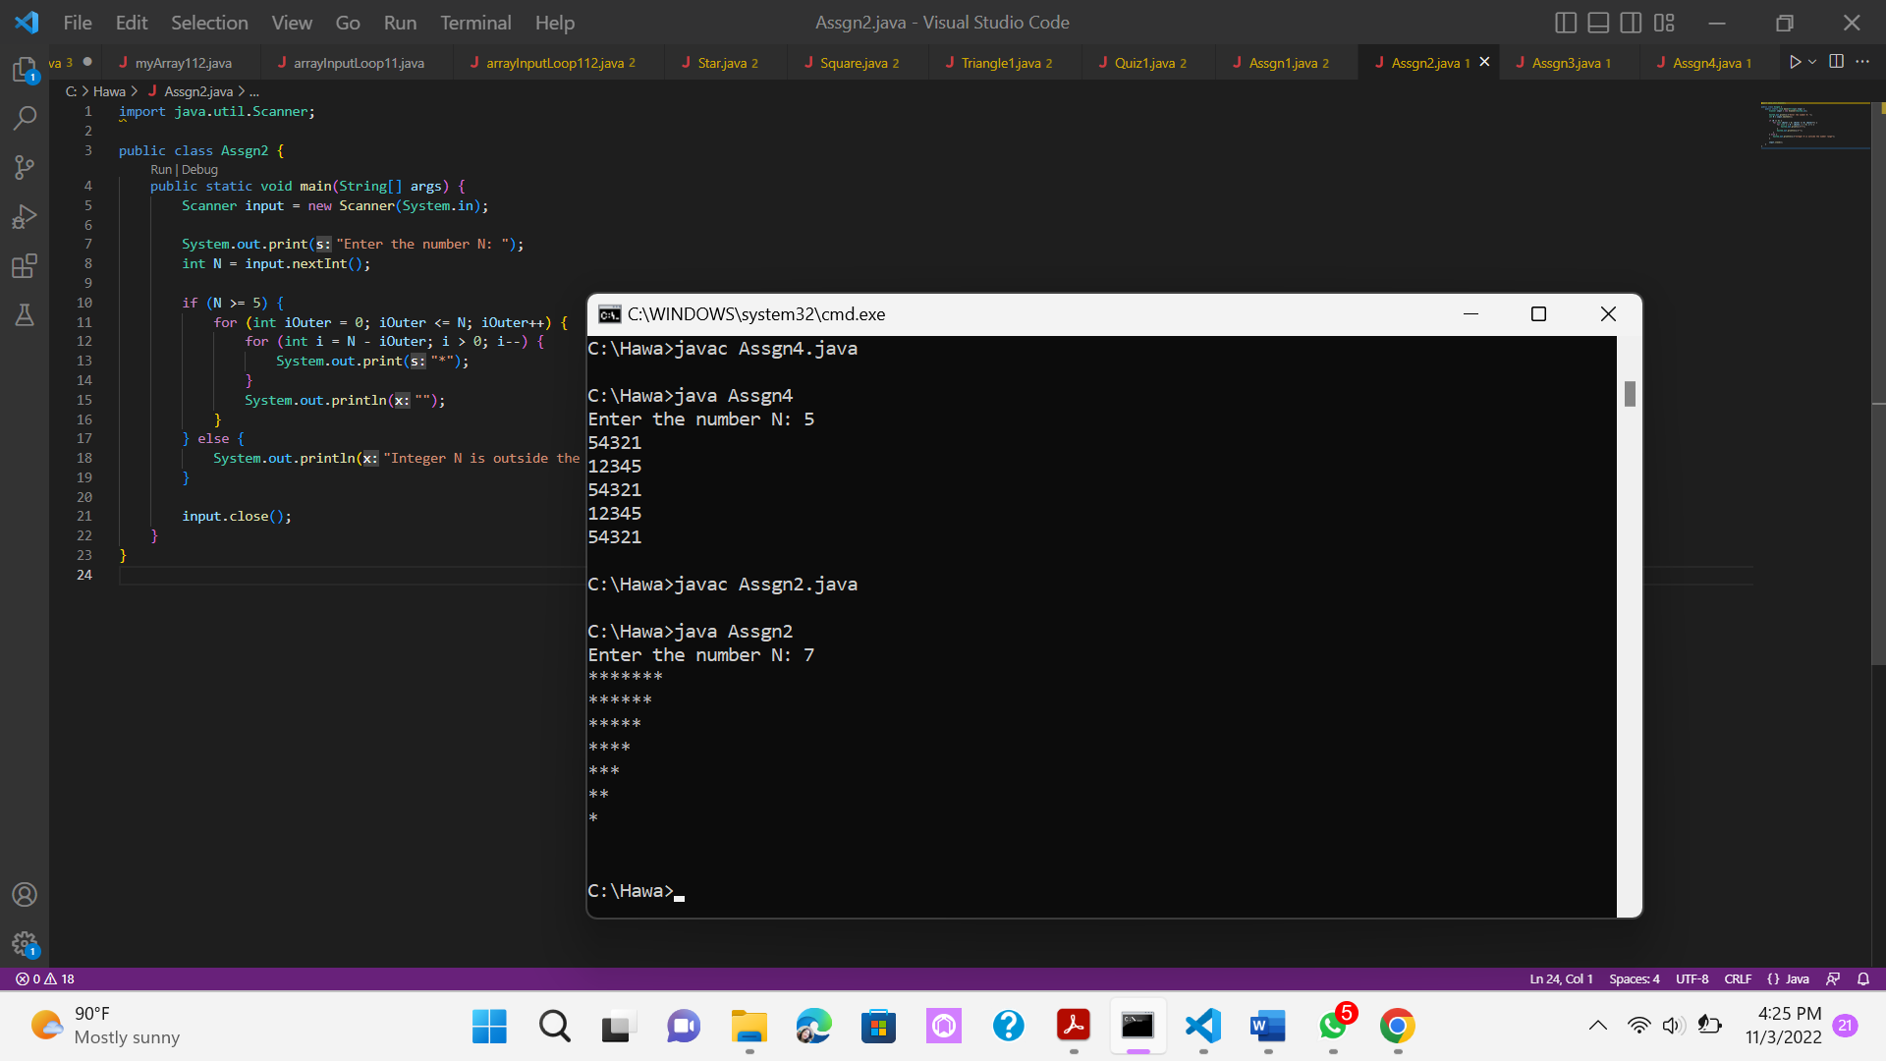

1. Create a program to print a square numeric display like the one below based on N input (minimum N value is 3). Example N = 3 and N = 5

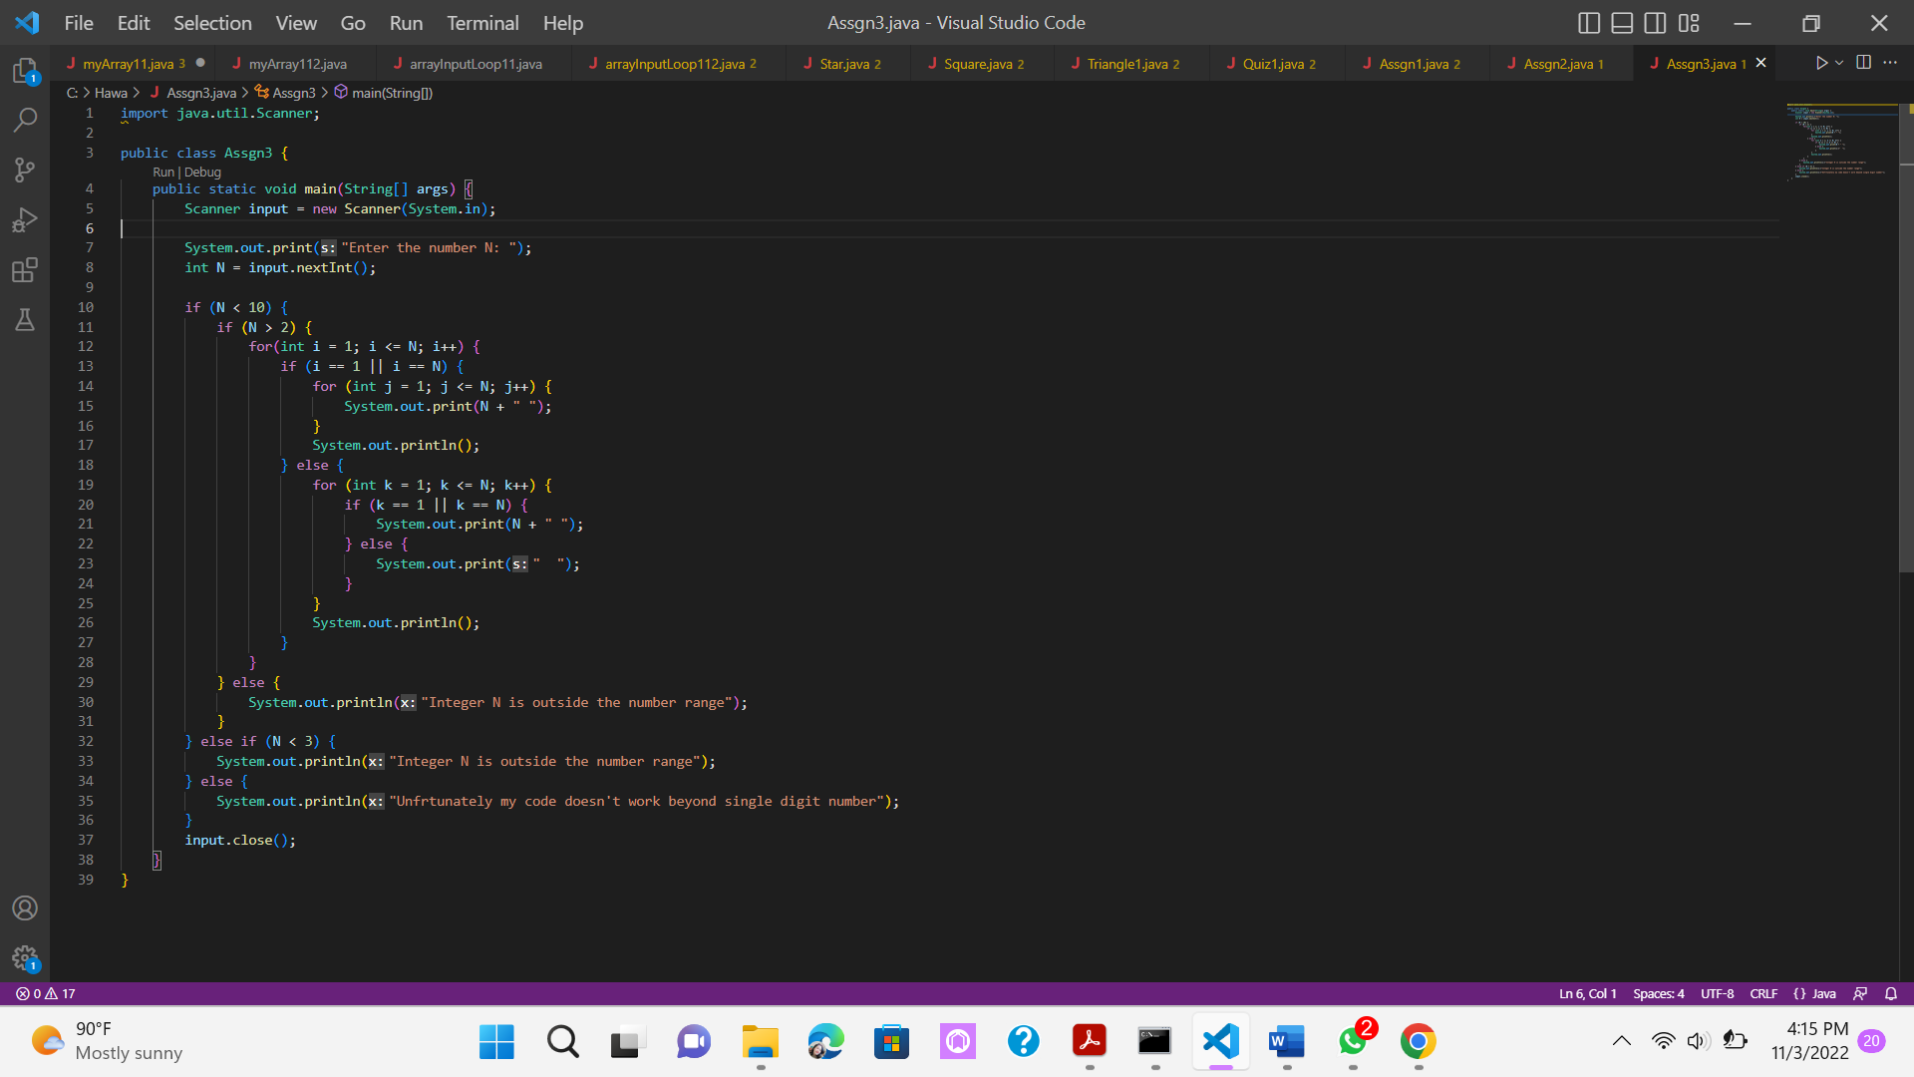

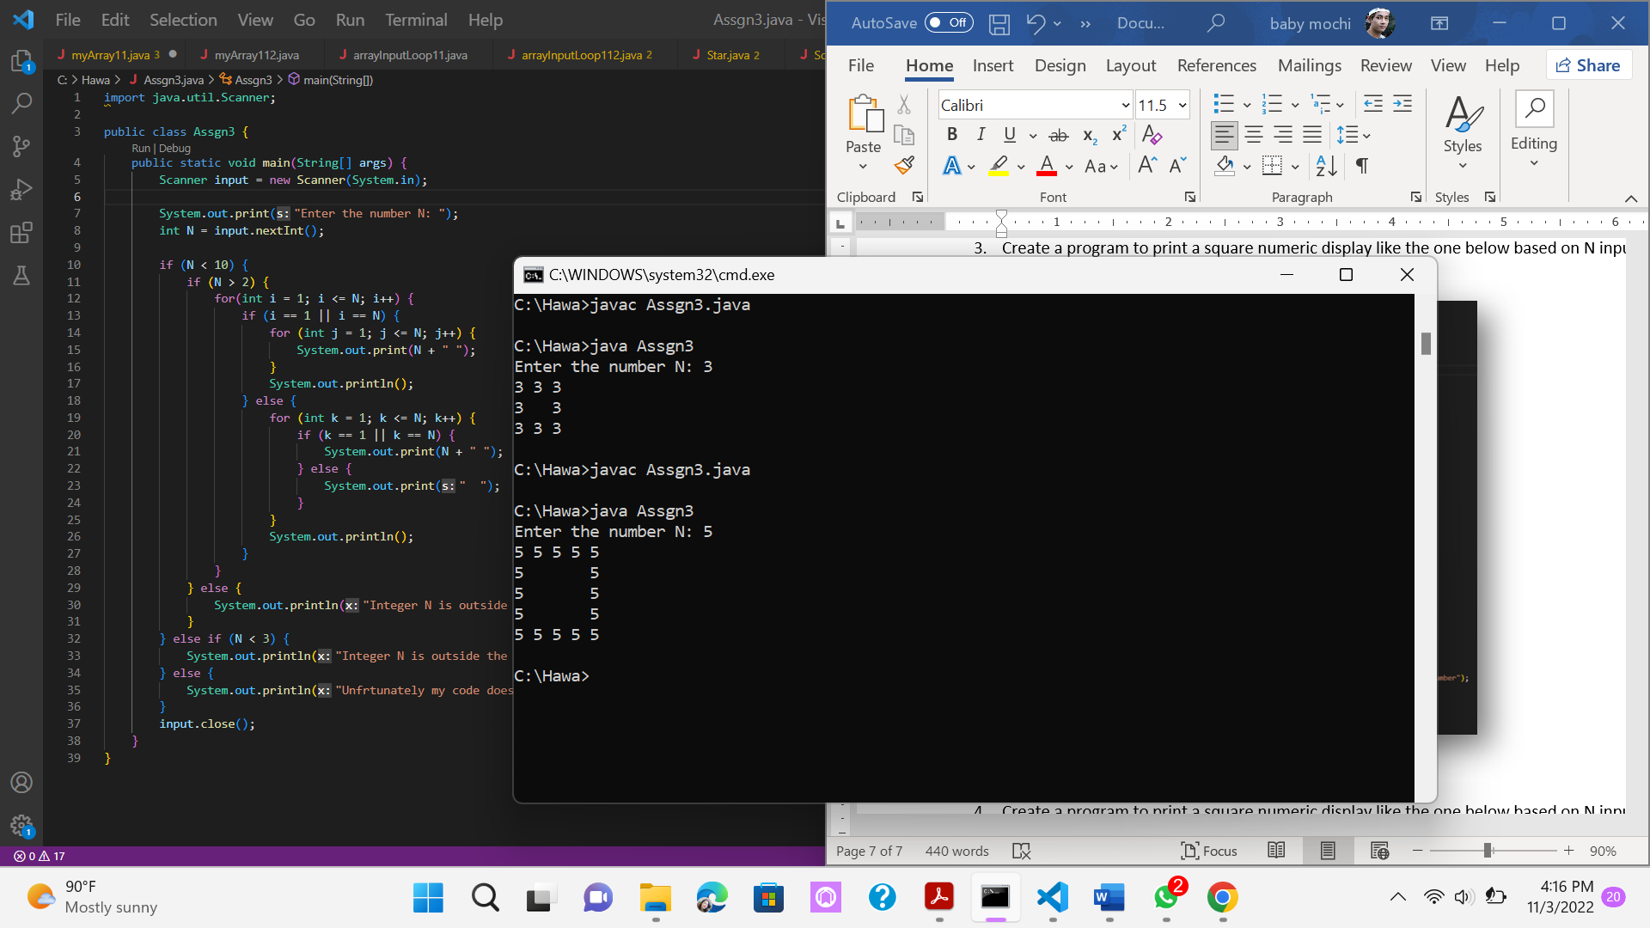

1. Create a program to print a square numeric display like the one below based on N input (minimum N value is 5). Example N = 5

